"OFFSHORE BREEZES"
From
PRINCE Edward IslanD

Published by
The Charlottetown Y Service Club
President: Ron Profit
Editor: Bill Irwin
Charlottetown, P.E.I.
Meetings: The Local every 2nd and 4th Thursdays (September- May) at 5:00 PM
Motto: “To Acknowledge the Duty that Accompanies Every Right”
--------------------------------------------------------------------------------------------------------------------------

Edition # 5 – October 30th, 2023
The Five Simple Rules To Be Happy
Free you heart from hatred
Free your mind from worries
Live simply
Give more
Expect less.
*************************************************************************************
At our last meeting, we had thirteen members present. The rest were either on a honeymoon, working, had relatives visiting or had accidents preventing them from attending. It was a good entertaining productive meeting! The highlight of the evening was, which could be a mini-series someday, was Hannah Bell’s presentation on how a young girl from England would go on to graduate from high school at the age of 15 and then would become a successful business woman and elected Member of the PEI Legislature. She certainly has seen many parts of the world! Thank you Hannah for sharing your story with us!
Norbert was back with us after his trip to Montreal to attend his 55th reunion of his McGill Graduating Class. Dave B. was back with us a few pounds lighter after finding a barber. Bob was on devotions and told us about the $20 bill. Tyler filled in for JoAnn on fines and took quite a bit of change from us all. Thanks to Earl for filling in on grace for Steve who was still honeymooning.
President Ron distributed the minutes from the recent Board Meeting and the list of Y Service Club Committees (16), Chairs and Memberships. He is still looking for a Chair of the “New Fundraising Ideas” Committee and a Club Vice President.
The meeting was going along nicely until the entertainment started up downstairs at 1900 hours. The guitar/harmonica player was difficult to compete with! More on this later! *************************************************************************************
WORDS OF WISDOM

Robinson Caruso is the only one to ever get his work done by Friday?

WINNER VS LOSER
The winner is always a part of the answer
The loser is always a part of the problem.
The winner always has a program.
The loser always has excuse.
The winner says, “Let me do that for you”.
The loser says,”That’s not my job,”
The winner sees an answer for every problem;
The loser sees a problem in every answer.
The winner sees green near every sand trap:
The loser sees two or three sand traps for every green.
The winner says,”It may be difficult , but it ‘s possible.”
The loser says,”It may be possible ,but it’s too difficult.”

Today’s Short Snapper

Why did the pony get sent to his room?

He would’t stop horsing around!

*************************************************************************************

1– November 9th
Chair – Halbert Pratt
Co-Chair and Grace- Tyler Larter
Devotions – Hannah Bell
Fines – John Massey
Program – Business and “A GettingTo Know You” with either Chris Annett or Sharon Veale or both of them!
2 – November 23rd
Chair – Ron Profit
Co-Chair and Grace– Dave Blacquire
Devotions – Sharon Veale
Fines – Norbert Stewart
Program – 98th Charter Night.We will also have an”I Did It My Way”with Donna Profit.
Location and Time: TBD
3 –December 7th – Christmas Party at Ron and Donna Profit’s
Chinese Food will be on the menu!
4 – December 14th – Board Meeting at Ron and Donna Profit’s at 5:30.
5 – October 26th 2024 – 39th Annual Food Drive
*************************************************************************************

Toonies For Youth News

Thank to Blair for keeping us up to date! As you can see, we had a big winner recently. . Earl takes over for November on the pickup. On the 26th, we had a non winner in the tune of $5,927. Keep on playing!!!
Sharon has agreed to contact several businesses in the Stratford area with the possibility of them putting in 50-50 boxes. Thanks Sharon for doing this!
*************************************************************************************

How’s That?
The President of the Service Club was addressing the assembled membership.” In most organizations” he said,” half the members do all the work and the other half do nothing, I am happy to say that in this club, we do the exact opposite.”

Food Drive Update

Aside from Earl having his sign stolen, all went well. The 38th Annual Food Drive is now history! The weather was perfect! Below is a photo of John Massey and yours truly who were Club members when we initiated the Food Drive in1986. Earl was the third,but I don’t have a photo of him working this year. Eric was the fourth. As you can see from the above,we are set for the next Food Drive. We are also all set to be on Compass on October 22nd!!!

I worked at Superstore in Charlottetown. The drivers from Pat and The Elephant were Chuck, who was the fellow who built the replacement Parking Lot Shelter for us, and Heather Taweel. She was a longtime photographer for the Guardian who used to be assigned to take our photos for such projects as the Pancake Breakfast. Her Mom went to school with Judy years ago and her grandfather was Rae Simmons who played clarinet with Don Messer and The Islanders years ago!!!! Small world!!!

I don’t have the bottom line yet as to what we received from so many generous folks.I will let you know soon! I was into the Food Bank on Tuesday, but the count was still taking place.
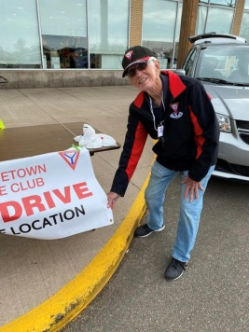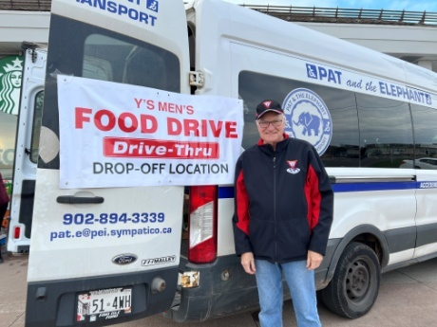

*************************************************************************************

How To Keep Earl Happy!
Earl is the Chair of the Building Fellowship Committee. One way to keep him happy is to give him your cancelled stamps. I wonder if he will get any cancelled Willie O’Ree stamps? This is the new one on the market of the. former professional hockey player from Fredericton, New Brunswick. He is widely recognized for being the first black player in the National Hockey League (NHL), playing as a winger for the Boston Bruins.
FYI, the Nashwaaksis Y Service Club meets at Willie O’Ree Place in Fredericton.

Editor’s Comments
The big news is that we will be starting our meeting next week – the 23rd at 5 PM which is an hour earlier than previous meetings. The reason is that the entertainment starts at 7 and we hope to be out of there by then.
Bye for now!
Y’sly
Bill

